62. Parent to Child-Calling Child Method from Parent and

Child to Parent Communication - 30 June 2022

Today we will learn:

1] Calling Child Method from Parent Component

2] Child to Parent Communication

3] Pass Data from Child to Parent Component

1] Parent to Child Communication:

Yesterday:



Calling Child Method from Parent Component

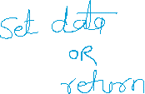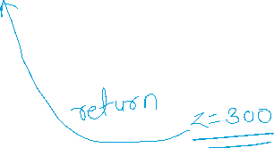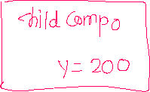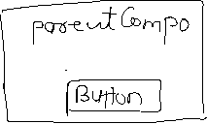

this.template.querySelector(‘c-child-compo’).M1();



User Story 1]

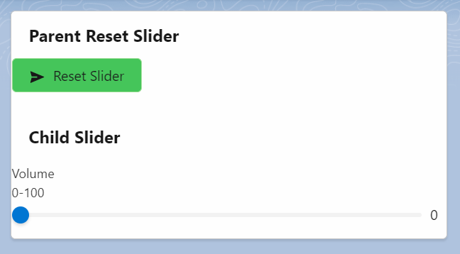

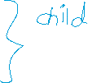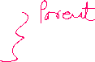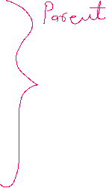

**Parent Compo** : resetSliderCompo

**Child Compo** : mySlider

Parent:

<template>

    <lightning-card title="Parent Reset Slider">

        <lightning-button variant="success" icon-name="utility:send" label="Reset Slider" onclick={resetButtonHandler}></lightning-button>

        <!-- Calling mySlider Component START -->

            <c-my-slider> </c-my-slider>

        <!-- Calling mySlider Component END -->

    </lightning-card>

</template>

import { LightningElement } from 'lwc';

export default class ResetSliderCompo extends LightningElement {

    receivedMessage='Waiting....!!!';

    resetButtonHandler(){

       this.template.querySelector('c-my-slider').resetMySliderValueHandler();

    }

}

Child:

<template>

    <lightning-card title="Child Slider">

        <lightning-slider label="Movie Volume" value={sliderValue}></lightning-slider>

    </lightning-card>

</template>

import { LightningElement,api } from 'lwc';

export default class MySlider extends LightningElement {

    sliderValue=10;

    @api resetMySliderValueHandler(){

        this.sliderValue = 0; //Reset Slider

    }

}